How to sign up as a Volunteer

STEP 1.
Start by going to the top of the Volunteer page and click Apply Now.
This will take you to a page on the Better Impact website.

.
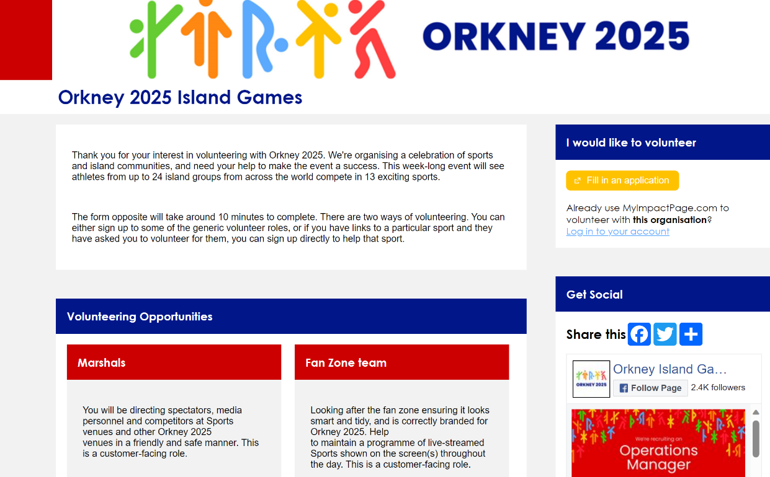

STEP 2. Click the yellow box.

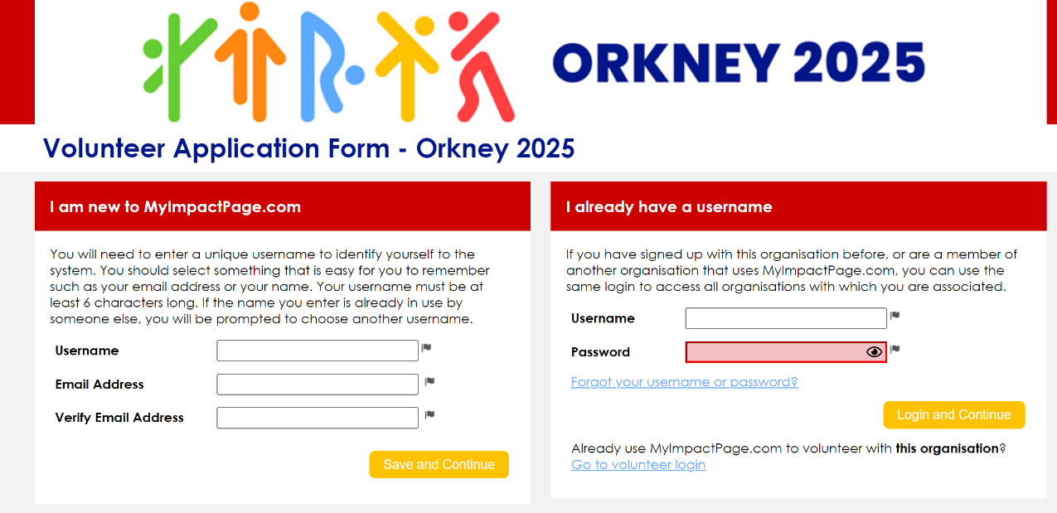
STEP 3.
Make up a username and fill in your email address. (You will need to use the username whenever you sign in again.)

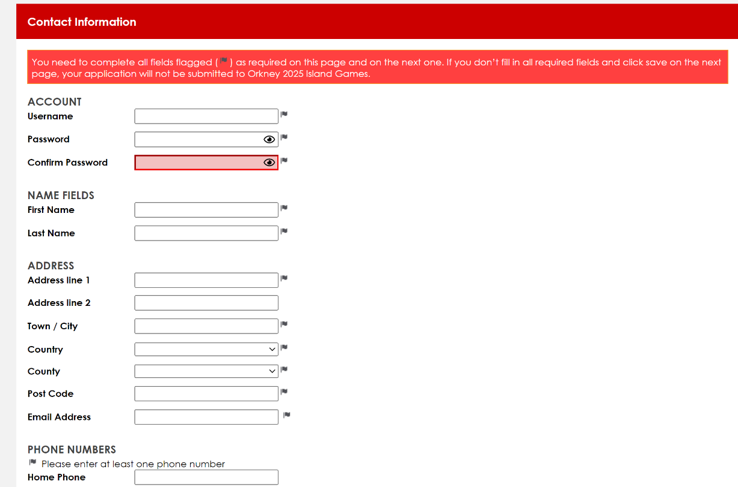

STEP 4.
Use your username from the previous page and make up a password.

STEP 5.
Then complete your personal details on the rest of the page.

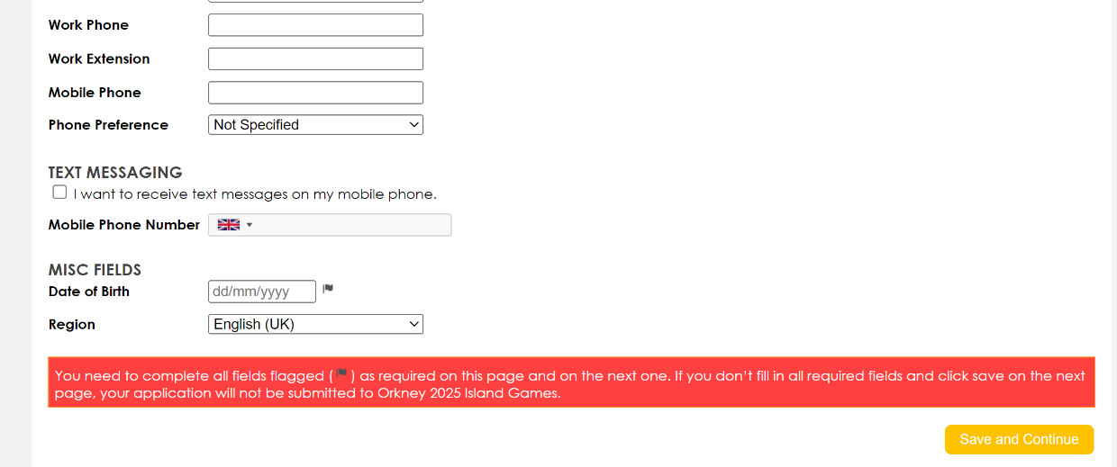
Let us know when we can contact you.

If you want to receive text messages, add your mobile number again here.

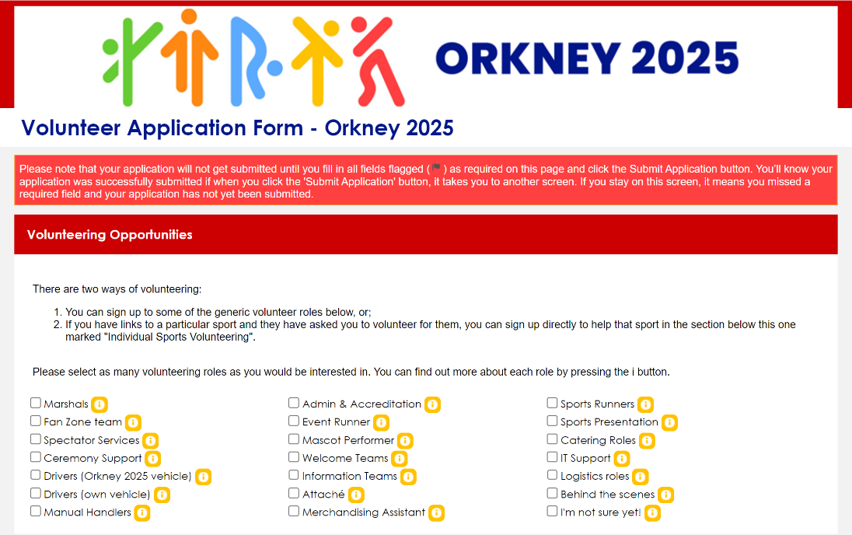

STEP 6.
Complete either this section for general volunteering opportunities…

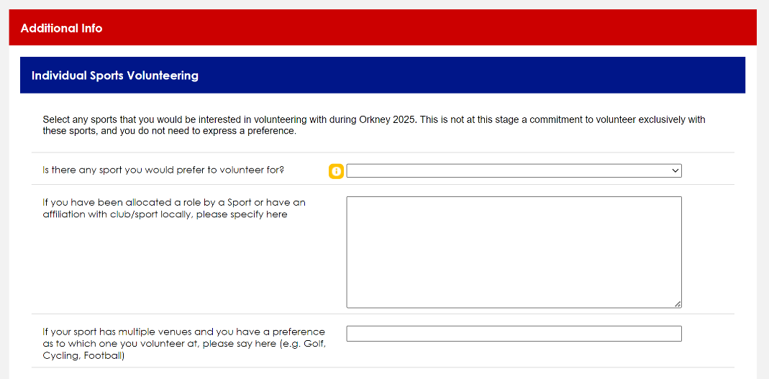
… Or this section if you’re affiliated to a particular Sport

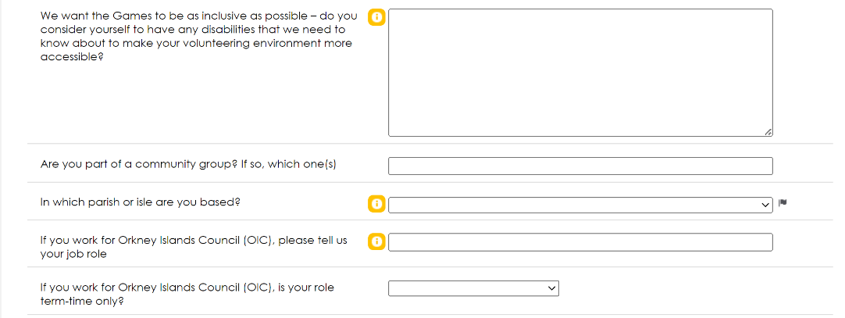
STEP 7.
Please answer the rest of the questions.

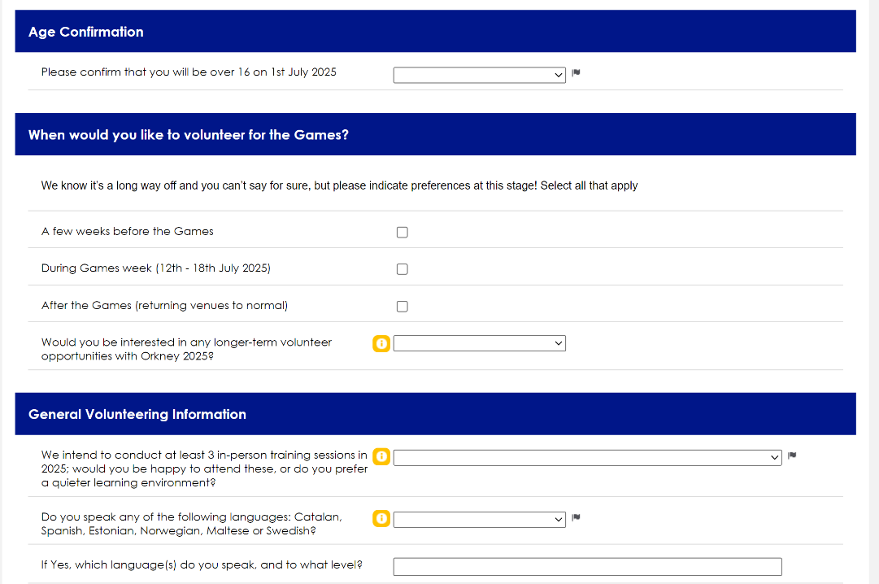

STEP 8.
Use the Personal Statement section to tell us anything us you want us to know.

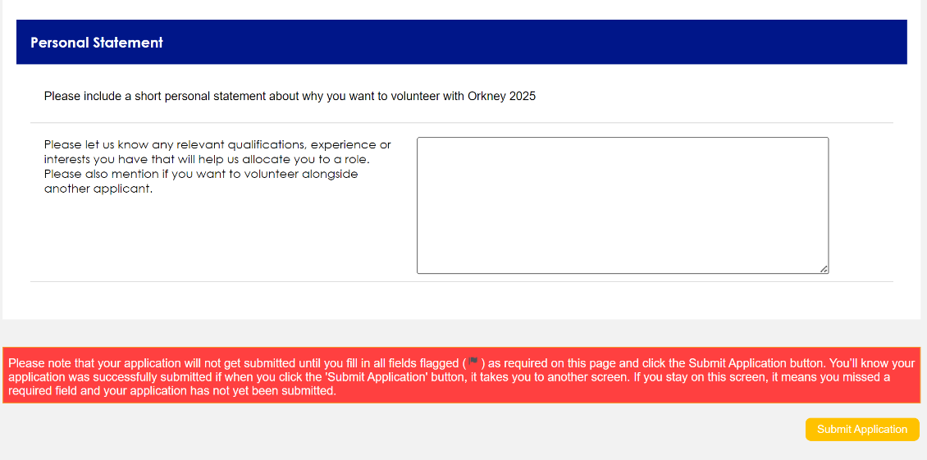
Last Step!
Click Submit Application.
You should receive an email acknowledging that we’ve received your application. We’ll be in touch with you after the application phase closes in September of this year.

